Quantitative Risk Analyst, 定量风险分析师

Your role
Do you like to apply advanced mathematics and programming skills to solve problems in the financial market? Are you an innovative thinker? We’re looking for someone like that who can:
• independently review models for Rates, FX, Credit Derivatives and Equities used in Investment bank
• examine/make suggestions to improve the model suitability, calibration, speed, accuracy, risk sensitivities and model performance under stressed market conditions
• analyze and approve complex transactions and model reserve methodologies
• develop benchmark models in C++
• work closely with front office quants, trading desks and other risk control teams

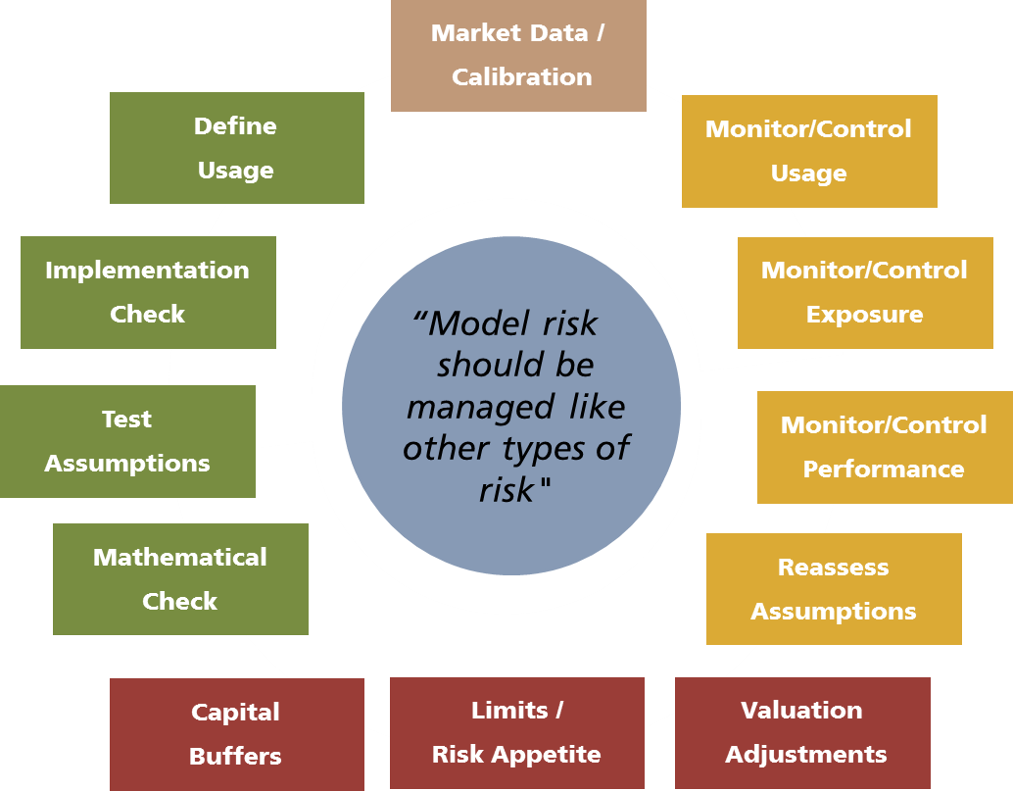
Your team
You’ll be working in the APAC team of the Model Risk Management and Control (MRMC) based in Shanghai. The main objective of the team is to work closely with other MRMC teams to validate the models used in investment bank.

Your experience and skills
You have:
– MSc or PhD in a quantitative discipline such as Mathematics, Physics, or Computing etc
– proficiency using C++/Python to implement derivatives pricing models (If you have very strong C++ programming background in other fields, you are welcomed to apply too)
– excellent written and verbal communication skills (able to explain equations in plain English)

You are:
– independent, pragmatic, concise and accurate, with strong attention to detail
– able to apply technical understanding to practical problems
– willing to collaborate and share knowledge with your team
How to Apply
visit ubs.com/careers, go to Asia Pacific and Professionals, search "quantitative risk analyst" in "China", and make the application online.

